**SOFTWARE DESIGN DOCUMENT (SDD)**

**Smart Health Insurance Management System (SHIMS)**

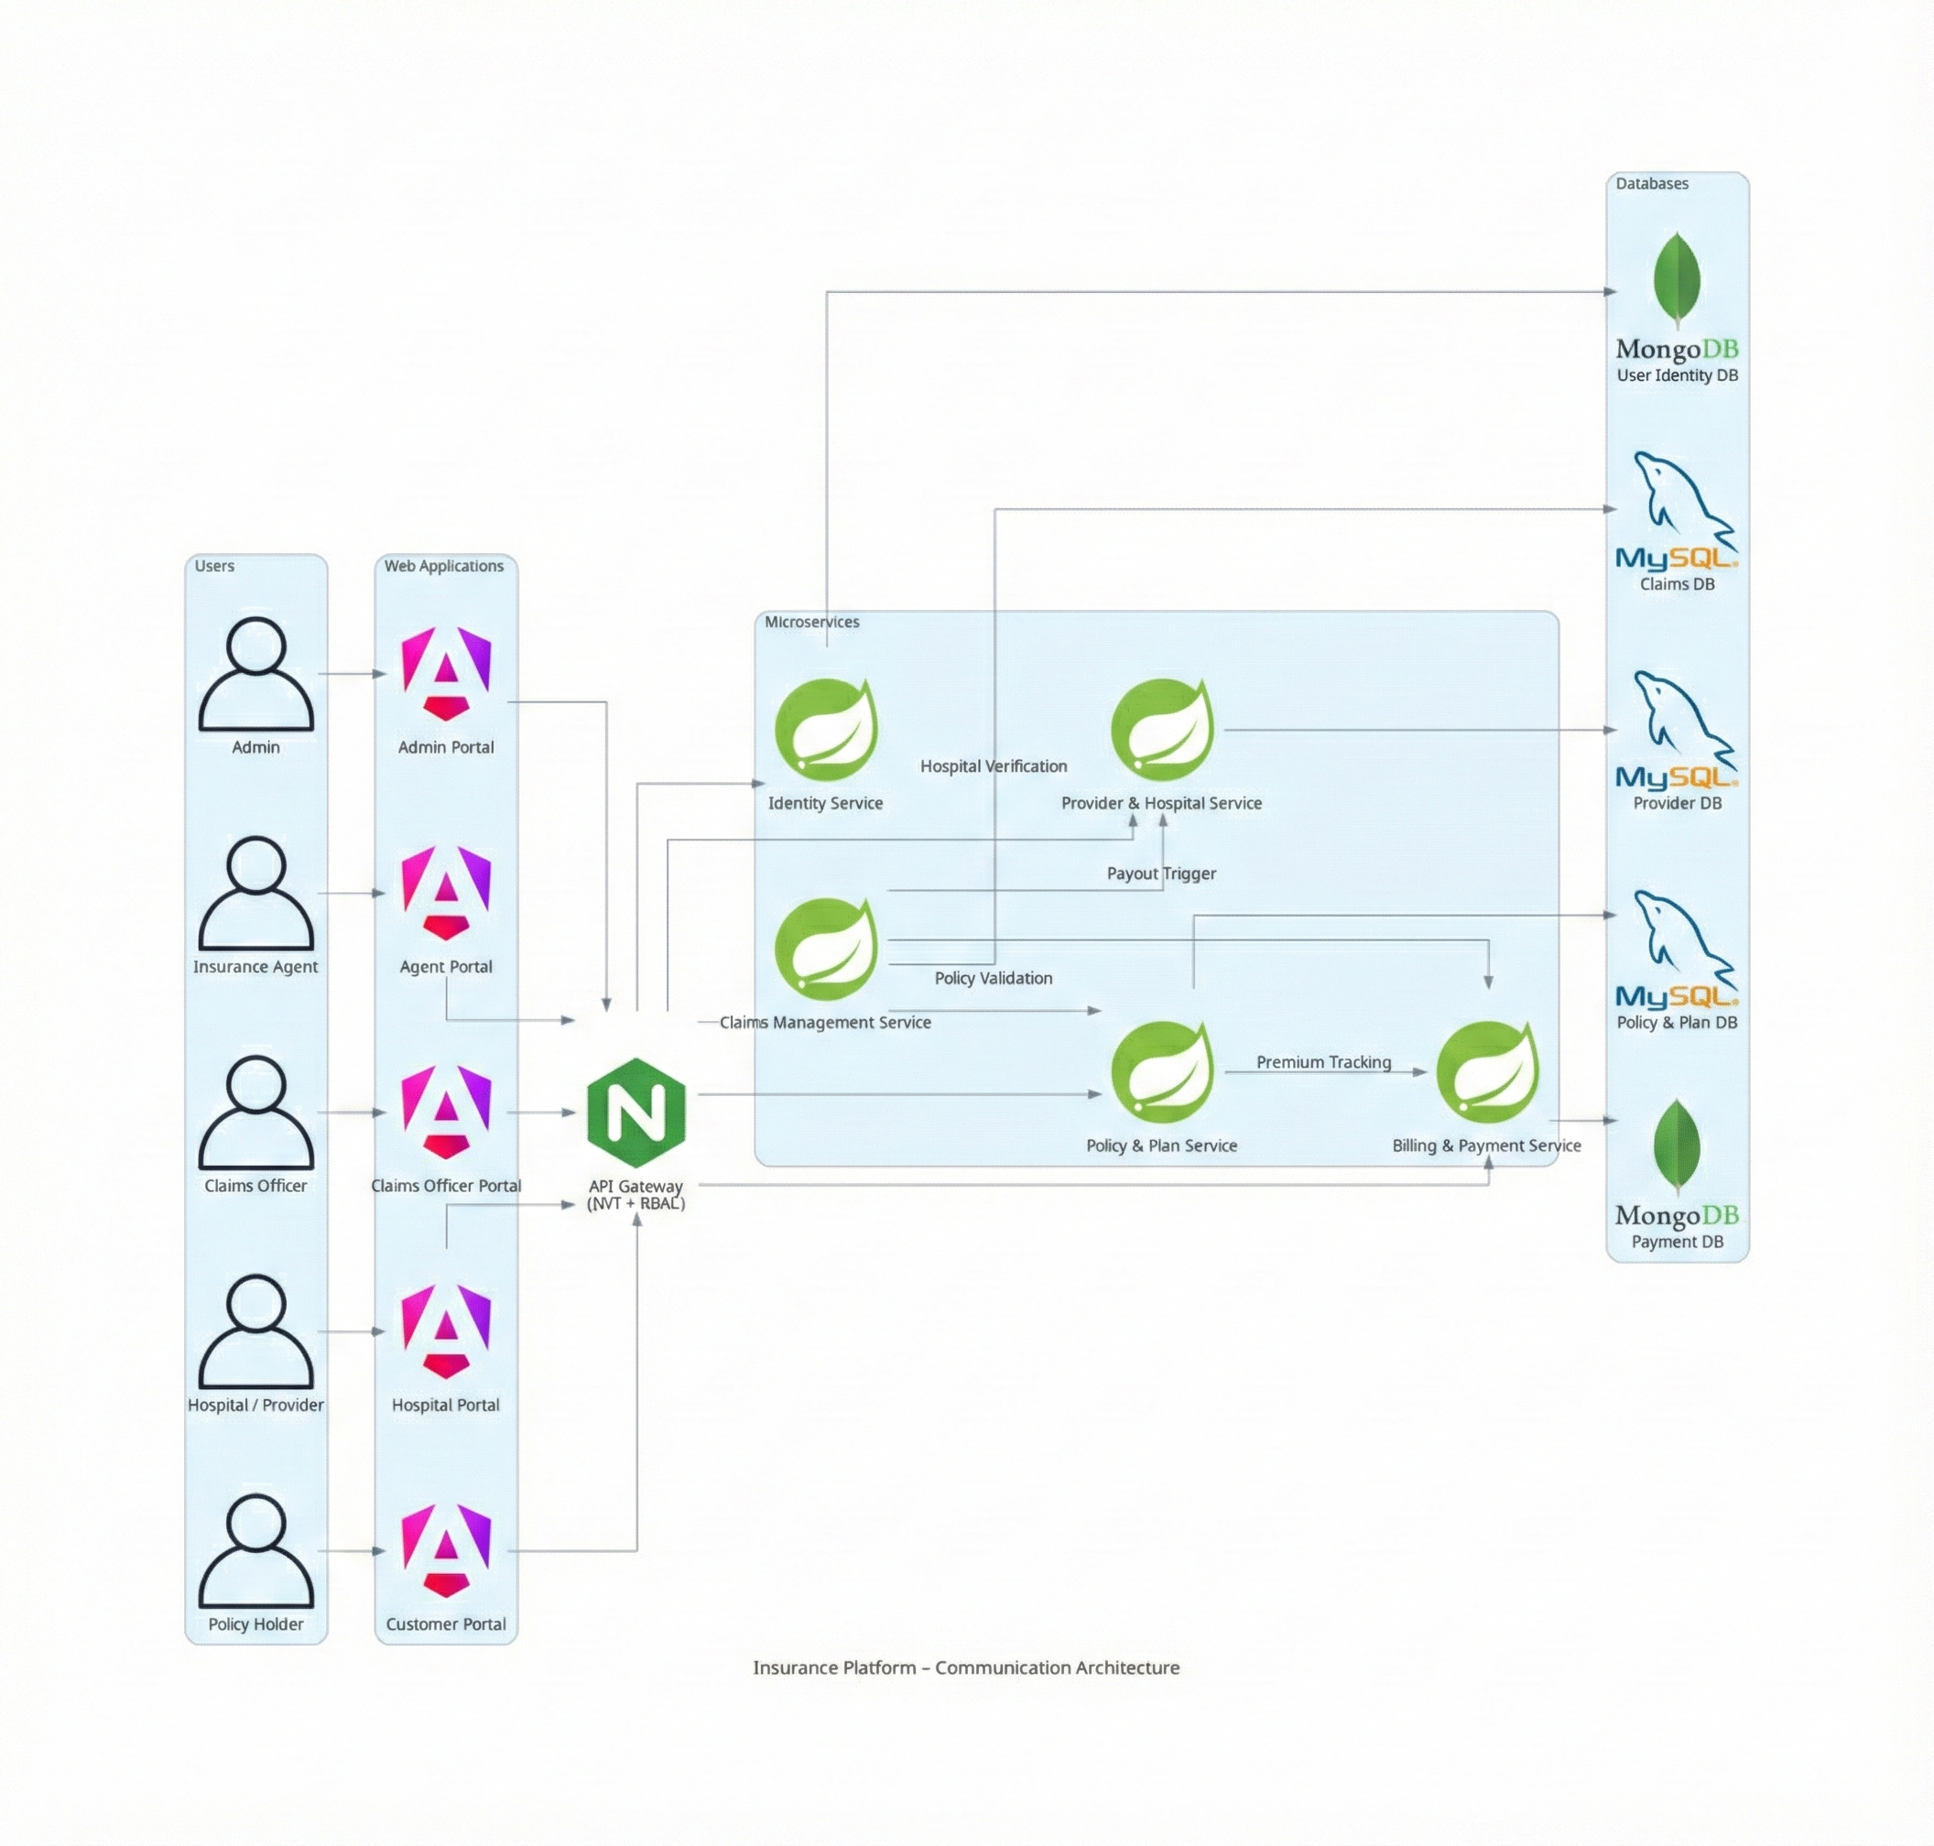 **Api Design =** <https://docs.google.com/spreadsheets/d/1Y7oRTD3BBCB2Aa30dHHE78SmYxiwv5_V2Q2DcRqtCEk/edit?usp=sharing>

**User Roles**

**Admin**

● Manage users, roles, insurance plans, hospitals, and policy rules

**Insurance Agent**

● Enroll customers and manage policy details

**Claims Officer**

● Review, approve, or reject insurance claims

**Hospital / Provider**

● Submit treatment details and insurance claims

**Policy Holder (Customer)**

● View policies, pay premiums, and track claims

**1. DOCUMENT CONTROL**

| **Item** | **Details** |
| --- | --- |
|  |  |
| Project Name | SHIMS |
| Version | 1.0 |
| Author | vishnu |
| Date | 27.12.2025 |
| Status | Initial |

**2. PURPOSE OF THE DOCUMENT**

This document describes the **system architecture, design decisions, component structure, APIs, data models, and non-functional aspects** of the Smart Order Management System.

It is intended for:

* Developers
* Reviewers
* Interview discussions
* Maintenance & enhancement planning

**3. SYSTEM OVERVIEW**

**Business Objective**

Provide a scalable, secure, and maintainable system to:

* Manage users
* Manage products
* Place and track policy and claims
* Support growth through microservices

### Core Architecture Principles:

* **Layered Backend:** Separates concerns into Controllers (API), Services (Business Logic), and Repositories (Data Access).
* **API-Driven:** All frontend interactions happen through secured RESTful endpoints.
* **DTO Pattern:** Data Transfer Objects are used to isolate internal database entities from the API layer.
* **Global Error Handler**

**4. ARCHITECTURE OVERVIEW (HLD)**

Mobile app/ Web -> store Front WebApp -> Api gateway -> Services

**Architecture Style**

* Microservices Architecture
* REST-based communication
* Containerized deployment (docker-compose / K8s)

**Core Components**

1. Angular Frontend
2. API Gateway (optional)
3. User Service
4. Policy Service
5. provider service
6. notification services
7. claims services
8. billing service
9. MongoDB/MySql (per service)
10. CI/CD Pipeline (Jenkins)

**5. TECHNOLOGY STACK**

**Backend**

* Java 21
* Spring Boot
* Spring Web
* Spring Data JPA
* Spring Validation

**Frontend**

* Angular
* Angular Material
* RxJS

**Database**

* SQL DB (One per service)

**DevOps**

* Docker
* Docker Compose / K8s
* Jenkins
* SonarQube

**Testing**

* JUnit 5
* Mockito
* Spring Boot Test
* Jasmine / Karma

**6. MICROSERVICES DESIGN**

**6.1 Identity Service**

**Responsibilities**

* User registration
* Authentication
* Role management

**Database**

* user_identity DB

**6.2 Policy & Plan Service**

**Responsibilities**

* Manages Catalogs of plans
* Policy Enrollments

**Database**

* Policy_plan DB

**6.3 Claims mgmt Service**

**Responsibilities**

* Manage Claims Lifecycle
* Policy validations upholding
* Claims status

**Database**

* Claims DB

**6.4 Provider & Hospital Service**

**Responsibilities**

* Manage Network Hospitals
* Claims status

**Database**

* Provider DB

**6.5 Billing & Payment Service**

**Responsibilities**

* Tracks Payments
* Claim payouts (Lifecycle -> Requires approval Claims Officer)
* Claims status

**Database**

* Payment DB

**6.6 Notification Service**

**Responsibilities**

* Sends notification to users /admin /claims officer / providers

**Database Diagram**

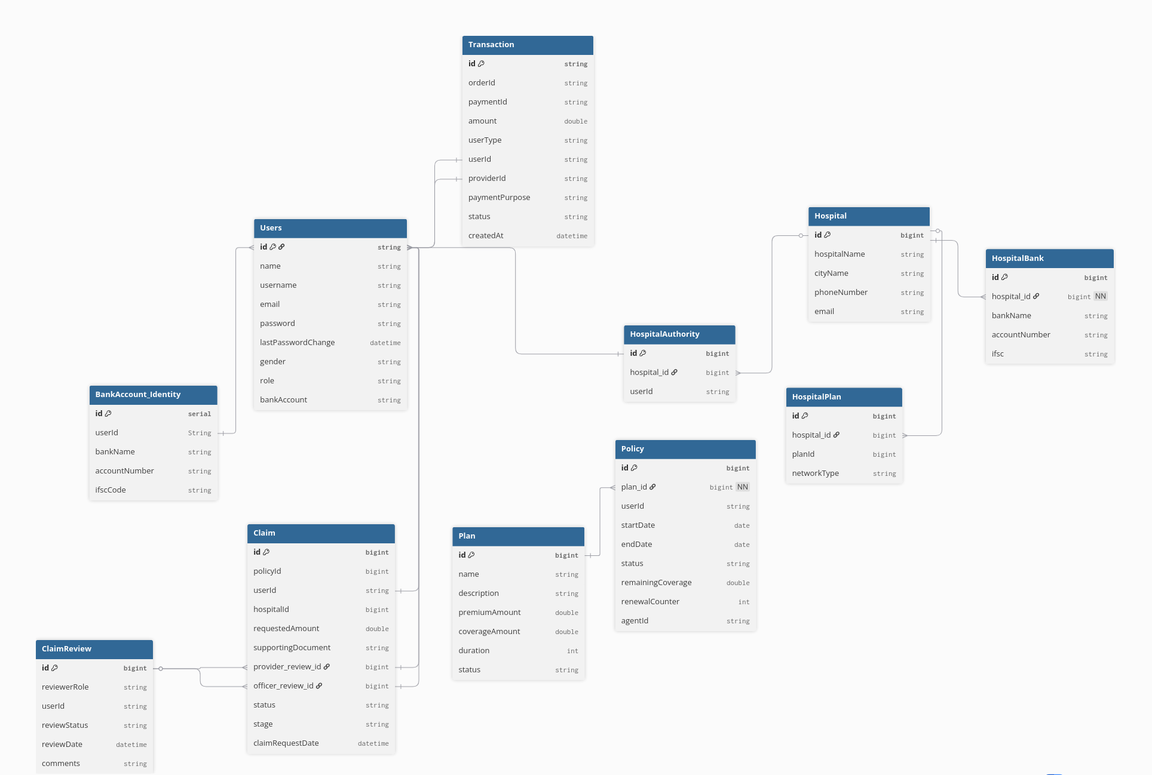

**7. DATA DESIGN (LLD)**

**User model**

{

"name": "vishnu 123",

"username": "vvishnu1231",

"email": "ante23e23eo@gmail.com",

"password": "abc12345",

"gender": "MALE"

}

**Insurance Plan model**

{

"name": "Silver Health Plan",

"description": "Comprehensive health insurance with high coverage",

"premiumAmount": 1500.0,

"coverageAmount": 500000.0,

"duration": 12,

"status": "ACTIVE",

"id": 2

}

**Policy (User enrollment) model**

{

"userId": "101",

"planId": "P1001",

"startDate": "2025-01-01",

"endDate": "2025-12-31",

"policyStatus": "ACTIVE",

"expiryAlertSent": false

}

**Claim model**

{

"policyId": "POL9001",

"userId": "101",

"providerId": "HSP200",

"claimAmount": 85000,

"claimStatus": "IN_REVIEW",

"submittedDate": "2025-02-15",

"approvedAmount": 80000

}

**Hospital model**

{

"providerId": "HSP200",

"providerName": "Apollo Hospital",

"city": "Bangalore",

"contactNumber": "+91-9876543210"

}

**Payment model**

{

“OrderId”: “ord123”

"paymentId": "PAY7001",

"policyId": "POL9001",

"userId": "101",

"amount": 12000,

"policyType": "PREMIUM",

"paymentStatus": "COMPLETED",

"paymentDate": "2025-01-01"

}

# DB design

## 1. Auth

Owns:

user db - user_table

Responsible:

user management and their functionalities

## 2. Policy Service

Owns:

policy db - plans_table, policytable

Responsible:

policy management and their functionalities

## 3. Claims Service

Owns:

claims db - claims_table, claims_revivew

Responsible:

claims management and the process

## 4.Provider Service

Owns:

Hospital db - provider_table, provider_authority, provider_bank, provider_plan

Responsible:

Providers management and their functionalities

## 5. Payment Service

Owns:

payment db – transactions_table, user_payout, provider_payout

Responsible:

Payment and related works

## 6. Notification Service

Responsible:

sending notification

**8. API DESIGN & VALIDATION**

* RESTful principles
* JSON request/response
* Bean Validation at DTO layer
* Service-level business rule enforcement
* Standard HTTP status codes

**Business Rules**  
  
User & Security

* User must be authenticated to access APIs
* Access is role-based
* Passwords are encrypted

Policy

* One user can have multiple policies
* Policy must be ACTIVE to use
* Policy expires after end date
* Policy renewal extends validity

Claims

* Claim must belong to a valid policy
* Claims not allowed for EXPIRED policies
* Claim follows lifecycle:  
  Submitted -> In Review -> Approved ->Paid / Rejected
* Only Claims Officer can approve/reject

Providers

* Only network hospitals can submit claims
* Providers cannot approve claims

Payments

* Premium payment required to activate policy
* Claim payout only after approval
* Payment status tracked (PENDING / COMPLETED)

**9. ERROR HANDLING STRATEGY**

**Global Exception Handling**

* Centralized using @ControllerAdvice
* Standard error response format

{

"timestamp": "2025-01-01T10:00:00",

"status": 400,

"error": "Validation Error",

"message": "Price must be greater than zero"

}

**10. SECURITY DESIGN**

* Password encryption (BCrypt)
* Role-based access control
* JWT authentication (optional enhancement)
* Secure API access

**11. NON-FUNCTIONAL REQUIREMENTS**

| **Area** | **Design Decision** |
| --- | --- |
| Scalability | Stateless services, Docker |
| Performance | Pagination, async calls |
| Availability | Independent services |
| Maintainability | POM-like layered backend |
| Security | Validation, encryption |
| Observability | Logging & monitoring |

**12. TESTING STRATEGY**

**Backend**

* Unit tests (Service layer)
* Controller tests (MockMvc)
* Minimum 90% coverage

**Frontend**

* Component tests
* Service tests

**Quality Gates**

* SonarQube enforced
* Build fails on violations

**13. CI/CD DESIGN**





**Pipeline Flow**

1. Git Commit
2. Jenkins Build
3. Unit Tests
4. SonarQube Scan
5. Quality Gate Check
6. Docker Build
7. Docker Compose Deploy

**14. DEPLOYMENT DESIGN**

* Docker image per microservice
* docker-compose for orchestration / k8s
* Environment-specific configs

**15. ASSUMPTIONS & CONSTRAINTS**

**Assumptions**

* Services communicate over REST
* mysql available
* Docker environment present

**Constraints**

* No distributed transactions
* Event-driven architecture out of scope

**16. FUTURE ENHANCEMENTS**

* Spring Cloud Gateway
* Kafka-based async communication
* Kubernetes deployment
* Centralized logging (ELK)

**17. CONCLUSION**

This design ensures:  
✔ Clean separation of concerns  
✔ Scalability & maintainability  
✔ Testability & CI/CD readiness  
✔ Interview-ready explanation

**\SEQUENCE DIAGRAMS — SMART Health Insurance MANAGEMENT SYSTEM**

Login/register:

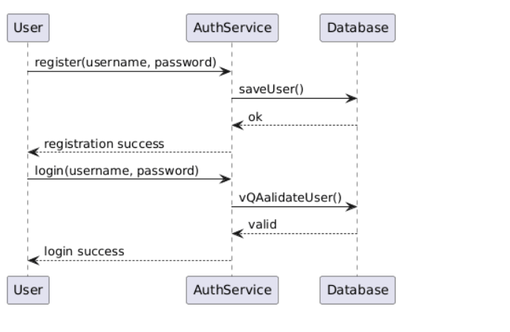

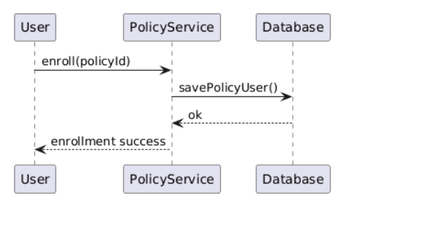  
Policy enrollment

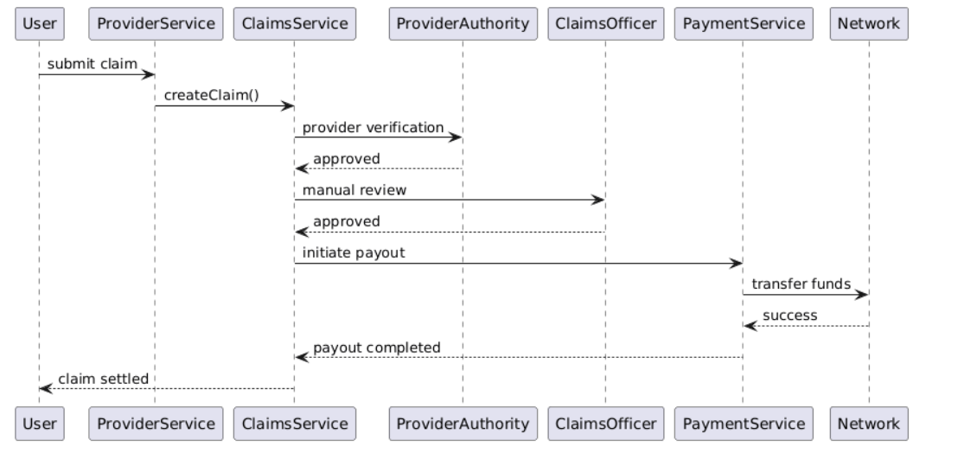Claim payouts

**6. CI/CD Pipeline — Sequence Diagram**





**Scenario**

Developer pushes code to Git repository.

**Flow**

1. Developer pushes code
2. Jenkins pipeline triggered
3. Jenkins runs unit tests
4. Jenkins runs SonarQube scan
5. Quality gate checked
6. Docker images built
7. Docker Compose deploys services

**Participants**

* Developer
* Git
* Jenkins
* SonarQube
* Docker

**7. Error Handling — Sequence Diagram**

**Scenario**

Invalid request sent to backend.

**Flow**

1. Angular sends invalid request
2. Controller validation fails
3. Global exception handler triggered
4. Standard error response returned

**Key Point**

* Consistent error structure across services

**SEQUENCE → CODE CLASS MAPPING**

**1) User Registration**

**Sequence Steps**

1. User submits registration form
2. API receives request
3. Validate input & business rules
4. Encrypt password
5. Persist user
6. Return response

**Code Mapping (User Service)**

| **Step** | **Layer** | **Class** | **Responsibility** |
| --- | --- | --- | --- |
| 1 | Angular | RegisterComponent | Collect form data |
| 2 | Angular | AuthService | POST /users/register |
| 3 | API | UserController | Request mapping |
| 4 | DTO | UserRegisterRequest | Bean validation |
| 5 | Service | UserService | Uniqueness checks |
| 6 | Security | PasswordEncoderConfig | BCrypt encryption |
| 7 | Repo | UserRepository | Save user |
| 8 | API | UserController | Return response |

**Key Methods**

* UserController.register(UserRegisterRequest)
* UserService.registerUser(...)
* UserRepository.existsByEmail(...)

**2) User Login**

**Sequence Steps**

1. Submit credentials
2. Fetch user
3. Verify password
4. Generate token (optional)
5. Return auth response

**Code Mapping**

| **Step** | **Layer** | **Class** | **Responsibility** |
| --- | --- | --- | --- |
| 1 | Angular | LoginComponent | Capture credentials |
| 2 | Angular | AuthService | POST /users/login |
| 3 | API | AuthController | Handle login |
| 4 | Repo | UserRepository | Find by email |
| 5 | Service | AuthService | Password match |
| 6 | Security | JwtTokenProvider | Create JWT |
| 7 | API | AuthController | Return token |

**Key Methods**

* AuthController.login(LoginRequest)
* AuthService.authenticate(...)

**3) Product Listing**

**Sequence Steps**

1. UI requests products
2. Fetch from DB
3. Return list

**Code Mapping (Product Service)**

| **Step** | **Layer** | **Class** | **Responsibility** |
| --- | --- | --- | --- |
| 1 | Angular | ProductListComponent | Load products |
| 2 | Angular | ProductApiService | GET /products |
| 3 | API | ProductController | Handle request |
| 4 | Service | ProductService | Business logic |
| 5 | Repo | ProductRepository | Query MongoDB |

**Key Methods**

* ProductController.getAllProducts()
* ProductService.findAll()

**4) Order Placement (Critical Flow)**

**Sequence Steps**

1. Place order
2. Validate request
3. Check stock
4. Reduce inventory
5. Create order
6. Persist & respond

**Code Mapping (Order + Product Services)**

| **Step** | **Service** | **Class** | **Responsibility** |
| --- | --- | --- | --- |
| 1 | Angular | CheckoutComponent | Submit order |
| 2 | Angular | OrderApiService | POST /orders |
| 3 | Order API | OrderController | Receive order |
| 4 | DTO | OrderRequest | Validate payload |
| 5 | Order Svc | OrderService | Orchestrate flow |
| 6 | Order Svc | ProductClient | Call Product Service |
| 7 | Product API | ProductController | Validate stock |
| 8 | Product Svc | InventoryService | Deduct quantity |
| 9 | Order Repo | OrderRepository | Save order |
| 10 | Order API | OrderController | Return result |

**Key Methods**

* OrderService.placeOrder(OrderRequest)
* ProductClient.checkAndReserveStock(...)
* InventoryService.reduceStock(...)

**5) Order Status Update (Admin)**

**Sequence Steps**

1. Admin updates status
2. Validate role
3. Validate transition
4. Update order

**Code Mapping**

| **Step** | **Layer** | **Class** | **Responsibility** |
| --- | --- | --- | --- |
| 1 | Angular | AdminOrderComponent | Update status |
| 2 | Angular | OrderApiService | PUT /orders/{id}/status |
| 3 | Security | JwtAuthFilter | Role validation |
| 4 | API | OrderController | Accept request |
| 5 | Service | OrderService | Validate transition |
| 6 | Repo | OrderRepository | Persist status |

**Key Methods**

* OrderService.updateStatus(orderId, status)
* OrderStatusValidator.isValidTransition(...)

**6) Global Validation & Error Handling**

**Sequence Steps**

1. Invalid input
2. Validation fails
3. Standard error response

**Code Mapping**

| **Step** | **Layer** | **Class** | **Responsibility** |
| --- | --- | --- | --- |
| 1 | DTO | @Valid annotations | Input validation |
| 2 | Framework | MethodArgumentNotValidException | Triggered |
| 3 | API | GlobalExceptionHandler | Build error response |

**Key Classes**

* GlobalExceptionHandler
* ApiErrorResponse

**7) CI/CD with SonarQube**

**Sequence Steps**

1. Git push
2. Build & tests
3. Sonar scan
4. Quality gate
5. Docker build
6. Deploy

**Code/Config Mapping**

| **Step** | **Tool** | **File/Class** |
| --- | --- | --- |
| 1 | Git | Repository |
| 2 | Jenkins | Jenkinsfile |
| 3 | Maven | pom.xml |
| 4 | SonarQube | sonar-project.properties |
| 5 | Docker | Dockerfile |
| 6 | Compose | docker-compose.yml |

**TRACEABILITY (WHY THIS MATTERS)**

* **Sequence step** → **Controller** → **Service** → **Repository**
* Every **business rule** is enforced **either in DTO validation or service logic**
* Easy to explain **end-to-end flow** in interviews

**How to explain succinctly**

“Each sequence diagram step maps directly to a controller endpoint, a service orchestration method, and a repository call. Validation is enforced at DTO and service layers, and failures are handled centrally.”

**CODE SKELETON — PACKAGES & CLASSES**

**1. USER SERVICE (user-service)**

user-service

└─ src/main/java/com/example/user

├─ UserServiceApplication.java

│

├─ controller

│ └─ UserController.java

│

├─ service

│ ├─ UserService.java

│ └─ UserServiceImpl.java

│

├─ repository

│ └─ UserRepository.java

│

├─ model

│ └─ User.java

│

├─ dto

│ ├─ UserRegisterRequest.java

│ ├─ LoginRequest.java

│ └─ UserResponse.java

│

├─ exception

│ ├─ UserNotFoundException.java

│ ├─ DuplicateUserException.java

│ └─ GlobalExceptionHandler.java

│

└─ config

└─ SecurityConfig.java

**Key Responsibilities**

* UserController → API layer
* UserService → Business rules
* UserRepository → MongoDB access
* SecurityConfig → Password encoding / JWT (optional)

**2. PRODUCT SERVICE (product-service)**

product-service

└─ src/main/java/com/example/product

├─ ProductServiceApplication.java

│

├─ controller

│ └─ ProductController.java

│

├─ service

│ ├─ ProductService.java

│ ├─ ProductServiceImpl.java

│ └─ InventoryService.java

│

├─ repository

│ └─ ProductRepository.java

│

├─ model

│ └─ Product.java

│

├─ dto

│ ├─ ProductRequest.java

│ └─ ProductResponse.java

│

└─ exception

├─ ProductNotFoundException.java

└─ GlobalExceptionHandler.java

**Key Responsibilities**

* InventoryService → Stock validation & update
* ProductServiceImpl → Core business logic

**3. ORDER SERVICE (order-service)**

order-service

└─ src/main/java/com/example/order

├─ OrderServiceApplication.java

│

├─ controller

│ └─ OrderController.java

│

├─ service

│ ├─ OrderService.java

│ ├─ OrderServiceImpl.java

│ └─ OrderStatusValidator.java

│

├─ client

│ ├─ ProductClient.java

│ └─ UserClient.java

│

├─ repository

│ └─ OrderRepository.java

│

├─ model

│ ├─ Order.java

│ └─ OrderItem.java

│

├─ dto

│ ├─ OrderRequest.java

│ ├─ OrderItemRequest.java

│ └─ OrderResponse.java

│

└─ exception

├─ OrderNotFoundException.java

└─ GlobalExceptionHandler.java

**Key Responsibilities**

* ProductClient → Calls Product Service
* OrderStatusValidator → Valid status transitions
* OrderServiceImpl → Orchestrates order flow

**4. COMMON / SHARED CONCEPTS (Optional)**

common

└─ src/main/java/com/example/common

├─ exception

│ └─ ApiErrorResponse.java

│

├─ util

│ └─ Constants.java

│

└─ config

└─ SwaggerConfig.java

**5. ANGULAR FRONTEND (angular-ui)**

angular-ui

└─ src/app

├─ core

│ ├─ services

│ │ ├─ auth.service.ts

│ │ ├─ product.service.ts

│ │ └─ order.service.ts

│ │

│ └─ guards

│ └─ auth.guard.ts

│

├─ modules

│ ├─ auth

│ │ ├─ login.component.ts

│ │ └─ register.component.ts

│ │

│ ├─ product

│ │ └─ product-list.component.ts

│ │

│ └─ order

│ ├─ checkout.component.ts

│ └─ order-history.component.ts

│

├─ shared

│ └─ models

│ ├─ user.model.ts

│ ├─ product.model.ts

│ └─ order.model.ts

│

└─ app.module.ts

**6. TEST STRUCTURE (IMPORTANT)**

src/test/java

└─ com/example

├─ controller

│ └─ UserControllerTest.java

├─ service

│ ├─ UserServiceTest.java

│ └─ OrderServiceTest.java

└─ repository

└─ ProductRepositoryTest.java

**7. DEVOPS & CI/CD FILES**

capstone-project

├─ Jenkinsfile

├─ docker-compose.yml

├─ user-service/Dockerfile

├─ product-service/Dockerfile

├─ order-service/Dockerfile

├─ angular-ui/Dockerfile

└─ README.md

**HOW TO EXPLAIN THIS IN INTERVIEWS**

“Each microservice follows a layered architecture: Controller → Service → Repository.  
Clients handle inter-service communication.  
DTOs isolate API contracts.  
Business rules live in the service layer.  
This makes the system scalable, testable, and maintainable.”

**STARTER REPO**





**1. REPOSITORY STRUCTURE (ROOT)**

smart-order-management/

│

├─ user-service/

├─ product-service/

├─ order-service/

├─ angular-ui/

│

├─ common/

│

├─ docker-compose.yml

├─ Jenkinsfile

├─ .gitignore

├─ README.md

You can create this repo **as-is** in GitHub.

**2. USER SERVICE (Spring Boot)**

user-service/

├─ src/main/java/com/example/user

│ ├─ UserServiceApplication.java

│ │

│ ├─ controller

│ │ └─ UserController.java

│ │

│ ├─ service

│ │ ├─ UserService.java

│ │ └─ UserServiceImpl.java

│ │

│ ├─ repository

│ │ └─ UserRepository.java

│ │

│ ├─ model

│ │ └─ User.java

│ │

│ ├─ dto

│ │ ├─ UserRegisterRequest.java

│ │ ├─ LoginRequest.java

│ │ └─ UserResponse.java

│ │

│ ├─ exception

│ │ ├─ DuplicateUserException.java

│ │ └─ GlobalExceptionHandler.java

│ │

│ └─ config

│ └─ SecurityConfig.java

│

├─ src/test/java/com/example/user

│ ├─ controller/UserControllerTest.java

│ └─ service/UserServiceTest.java

│

├─ Dockerfile

├─ pom.xml

└─ application.yml

**3. PRODUCT SERVICE**

product-service/

├─ src/main/java/com/example/product

│ ├─ ProductServiceApplication.java

│ ├─ controller/ProductController.java

│ ├─ service

│ │ ├─ ProductService.java

│ │ ├─ ProductServiceImpl.java

│ │ └─ InventoryService.java

│ ├─ repository/ProductRepository.java

│ ├─ model/Product.java

│ ├─ dto/ProductRequest.java

│ └─ exception/GlobalExceptionHandler.java

│

├─ src/test/java/com/example/product

│ └─ service/ProductServiceTest.java

│

├─ Dockerfile

├─ pom.xml

└─ application.yml

**4. ORDER SERVICE**

order-service/

├─ src/main/java/com/example/order

│ ├─ OrderServiceApplication.java

│ ├─ controller/OrderController.java

│ ├─ service

│ │ ├─ OrderService.java

│ │ ├─ OrderServiceImpl.java

│ │ └─ OrderStatusValidator.java

│ ├─ client

│ │ ├─ ProductClient.java

│ │ └─ UserClient.java

│ ├─ repository/OrderRepository.java

│ ├─ model

│ │ ├─ Order.java

│ │ └─ OrderItem.java

│ └─ dto/OrderRequest.java

│

├─ src/test/java/com/example/order

│ └─ service/OrderServiceTest.java

│

├─ Dockerfile

├─ pom.xml

└─ application.yml

**5. ANGULAR FRONTEND**

angular-ui/

├─ src/app

│ ├─ core

│ │ ├─ services

│ │ │ ├─ auth.service.ts

│ │ │ ├─ product.service.ts

│ │ │ └─ order.service.ts

│ │ └─ guards/auth.guard.ts

│ │

│ ├─ modules

│ │ ├─ auth

│ │ │ ├─ login.component.ts

│ │ │ └─ register.component.ts

│ │ ├─ product/product-list.component.ts

│ │ └─ order/checkout.component.ts

│ │

│ └─ shared/models

│ ├─ user.model.ts

│ ├─ product.model.ts

│ └─ order.model.ts

│

├─ Dockerfile

└─ angular.json

**6. DOCKER COMPOSE**

version: '3.8'

services:

mongodb:

image: mongo

ports:

- "27017:27017"

user-service:

build: ./user-service

ports:

- "8081:8081"

depends_on:

- mongodb

product-service:

build: ./product-service

ports:

- "8082:8082"

depends_on:

- mongodb

order-service:

build: ./order-service

ports:

- "8083:8083"

depends_on:

- mongodb

angular-ui:

build: ./angular-ui

ports:

- "4200:80"

**7. JENKINSFILE (CI/CD + SONARQUBE)**

pipeline {

agent any

stages {

stage('Checkout') {

steps { git 'https://github.com/your-org/smart-order-management.git' }

}

stage('Build & Test') {

steps { sh 'mvn clean test' }

}

stage('SonarQube Scan') {

steps {

withSonarQubeEnv('SonarQube') {

sh 'mvn sonar:sonar'

}

}

}

stage('Quality Gate') {

steps {

timeout(time: 2, unit: 'MINUTES') {

waitForQualityGate abortPipeline: true

}

}

}

stage('Docker Build & Deploy') {

steps {

sh 'docker-compose up -d --build'

}

}

}

}

**8. README.md (MINIMAL TEMPLATE)**

# Smart Order Management System

## Tech Stack

- Spring Boot Microservices

- Angular

- MongoDB

- Docker

- Jenkins + SonarQube

## Run Locally

docker-compose up -d

## Services

- User Service: 8081

- Product Service: 8082

- Order Service: 8083

- UI: http://localhost:4200

Map **design → code structure**

Tell me what you want to generate next.